Young Adult Reads- LGBTQ

Fiction

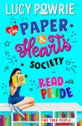
The Paper & Hearts Society: Read with Pride: Book 2
The much anticipated second book in The Paper & Hearts Society series by Booktuber Lucy Powrie. Will you be the next recruit for The Paper & Hearts Society book club? For fans of Holly Smale and Super Awkward.

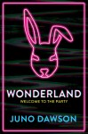
Wonderland
What happens when you fall down the rabbit hole? Wonderland is the compulsive must-have follow-up to CLEAN and MEAT MARKET from bestselling, award-winning author Juno Dawson. A searing exploration of mental health, gender and privilege, from the most addictive YA novelist in the UK today.

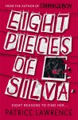
Eight Pieces of Silva (published early August)
From the multi-award-winning author of Orangeboy, an addictive mystery that refuses to let you go long after you turn the final page. Can Becks piece the jigsaw together and find her sister before Silva loses herself?

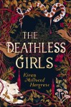
The Deathless Girls
Gothic, feminist and romantic – new YA novel The Deathless Girls is the breathtakingly imagined untold story of the brides of Dracula, by bestselling author Kiran Millwood Hargrave, author of The Girl of Ink and Stars.

Becoming Dinah
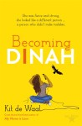
A YA coming-of-age road trip novel about obsession, self-discovery, female power, and the people we meet along the way. Becoming Dinah is the perfect read for anyone who’s ever wondered where they came from and where they might be going next. In her first YA novel, Costa-shortlisted author Kit de Waal responds to the classic Moby Dick with entirely new characters, a VW campervan, and by tearing the power away from obsessive Captain Ahab and giving it to a teenage girl who’s determined to find a new life, far away from her unconventional upbringing.

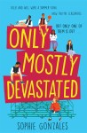
Only Mostly Devastated

The utterly joyful Only Mostly Devastated is a perfectly formed, laugh-out-loud rom com that features two unforgettable protagonists. Ollie and Will were a summer fling; now they’re classmates. But only one of them is out…SIMON VS THE HOMO SAPIENS AGENDA meets a modern-day, queer re-imagining of GREASE.

Heartstopper

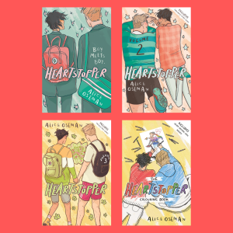
The bestselling Heartstopper graphic novel series by Alice Oseman is the completely charming story of two students at an all-boys grammar school in Kent, Nick, a soft-hearted rugby lad, and Charlie, an openly gay over-thinker. Friendship blooms quickly, but could there be something more…? Heartwarming and funny, you’ll fall head over heels for this is sweetly romantic story of LGBTQ+ love.

Read the story in Volumes 1, 2, 3

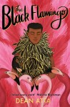
The Black Flamingo
A coming of age story told in verse, The Black Flamingo by Dean Atta follows Michael through school and to university as he comes to terms with his identity as a mixed-race gay teen and finds his wings as a drag artist. A bold story about the journey to self-acceptance and the power of embracing your uniqueness. Perfect for fans of Sarah Crossan and The Poet X.

Non-fiction

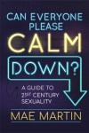
Can Everyone Please Calm Down?: A Guide to 21st Century Sexuality

Why do we find sexuality so, well … scary? Comedian Mae Martin investigates in this hilarious and intelligent guide to 21st century sexuality. Can Everyone Please Calm Down? covers everything from the pros and cons of labels, to coming out and the joys of sexual fluidity, Mae ponders all the stuff we get hung up about – and then a bit more.

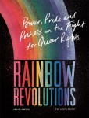
Rainbow Revolutions
From the impassioned speeches of bold activists Karl Ulrichs and Audre Lorde to the birth of Pride and queer pop culture, Rainbow Revolutions charts the dramatic rise of the LGBTQ+ rights movement, and celebrates the courageous individuals who stood up and demanded recognition. With bold and beautiful illustrations by pop artist Eve Lloyd Knight.

From Prejudice to Pride
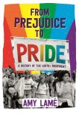
Available this year in an updated paperback format, From Prejudice to Pride was the first LGBTQ+ history book for young readers published in the UK, and is a library essential. Filled with photographs documenting LGBTQ+ life from the past and present, and from around the world, this book will inspire courage and pride in young LGBTQ+ people and help answer questions for all readers interested in gender and identity.

